On line version: http://www.msnbc.msn.com/id/5093131/site/newsweek/
Text version on newsstands: 1 June 2004

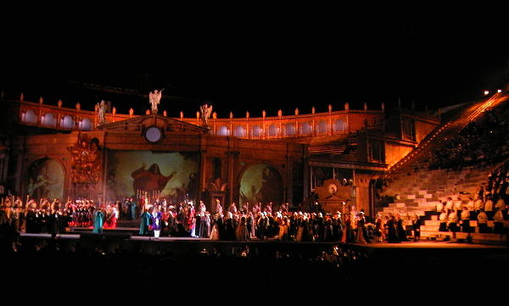
Opera in the Arena di Verona

Hidden Arias
Can't get a ticket to Glyndebourne? Don't despair. Other good opera abounds.
By Andrew Moravcsik
Newsweek
June 7-14 issue - Of the 2 million fans who will attend an opera in Europe this summer, one third will visit a single spot: the ancient Roman arena of Verona, where the performances are crowd-pleasing ("Aida," "La Boheme"), the stagings monumental, the casts strong, the sound clear and the setting incomparably romantic. Few who have gone can forget the sight of 16,000 spectators holding candles as the overture begins, in keeping with local tradition.

Many, however, seek a more intimate encounter. The real promise of summer opera, after all, is that a peaceful and leisurely setting will concentrate our minds on the esthetic experience in a way that running to the theater after work cannot. For such listeners, the first thought is often: how can I get a ticket to one of the "big three" European opera festivals—Bayreuth in Germany, Glyndebourne in Britain or Salzburg in Austria? If you have to ask, forget it. Would-be pilgrims to Bayreuth, where Wagner's operas are performed in a theater the composer designed, should start planning now for the summer of 2014. At Glyndebourne, only "friends" of the festival—i.e., those who contribute big wads of cash—get new tickets. And the management has even closed the waiting list for those who want to give money. A ticket to Salzburg can run you $400.

Do not despair, opera fans. There are plenty of other deeply stirring performances to be enjoyed this summer. The trick is to find the out-of-the-way spots where innovative musicians—often with younger singers—are setting the agenda. NEWSWEEK scouted out five current operatic trends and the best places to experience them:

Resurgent Russia: The Soviet bloc developed a superb system for training young talent in opera (as in chess). With the collapse of communism, young Russian and Eastern European singers have taken over stages around the world. Now, under the dynamic leadership of superstar conductor Valery Gergiev, the 221-year-old Mariinsky Opera Company in St. Petersburg has vaulted again to the eminence it held a century ago. This year it performs Verdi and an entire Wagner "Ring," as well as under-appreciated Russian repertoire in which it reigns supreme.

Bravo baroque: The operatic world has recently rediscovered baroque opera from the 17th and early 18th centuries. Works by Handel, Rameau, Scarlatti and other long-neglected opera composers are being performed again. That's good news for the generation of vocalists taught to sing in the subtly enchanting baroque style, accom-panied by delicate "original" instruments—violins with gut strings, horns without valves. The top spot for baroque opera is Beaune, two hours from Paris on the TGV. This summer some of baroque's best conductors—William Christie, Marc Mankowski and Sigiswald Kuijken—will be on the podium, and the food and wine of Burgundy are just outside the door.

For details of this summer's offerings:
• operabase.com: The essential resource, with programs, cast lists, ticket information and links for nearly all opera houses.
• operacast.com: A comprehensive list of Webcast operas for stay-at-home fans.
• mariinsky.ru/en: THe Mariinsky Theatre's 'White Nights Festival' in St. Petersburg (May 30-July 18).
• festivalbeaune.com: Festival de Musique Baroque in Beaune, France (July 2-Aug. 1).
• carmeninsevilla.com/english: The First Annual Seville Music Festival (Sept. 2-12).
• staatsoper.de: The Munich Opera Festival (July 2-31).

Opera on location: There is nothing more magical than seeing a performance in the place where the story was originally set—"Turandot" in Beijing, for instance, or "Aida" at the pyramids. This year Seville launches a new music festival with Bizet's "Carmen," the most performed opera in history. But since this tragic opera about a sultry cigarette girl and her macho men is set in Seville, each act will be performed on a separate outdoor stage near its location in the story, with the final act taking place in the city's celebrated bullfighting arena. The performances, conducted by Loren Maazel and cast with dashing divas, will last most of the night, with breaks between acts for the cast and audience to stroll to the next venue, sampling tapas along the way.
Italy's bright lights: The country that invented opera hardly performs it anymore, with many opera houses indigent, disorganized or dark. Two vibrant exceptions: the Festival Puccini in Torre del Lago and the Rossini Opera Festival in Pesaro. Each presents world-class opera devoted entirely to one composer in a town where he lived. This year the popular tenor Andrea Bocelli will sing Puccini in Torre del Lago's vast open-air theater on the shore of lovely Lake Massaciuccoli, near the Italian Riviera. At Pesaro on the Adriatic Sea, the singing is more refined and the theater an 18th-century jewel.
Some things never change: For traditionalists, there is Munich—the timeless home of serious opera expertly performed. Munich has three antique opera houses, each an acoustic and visual marvel. The Bavarian State Opera, as good as any company in Europe, devotes the month of July to festival programming, one opera a night. Tickets are moderately priced, but the casting is world class, often the same names as in nearby Bayreuth and Salzburg. One could take the train to see Mozart's house or Wagner's theater and easily return to Munich in time for dinner and the opera—all for less than the price of one mediocre seat at the two neighboring festivals.

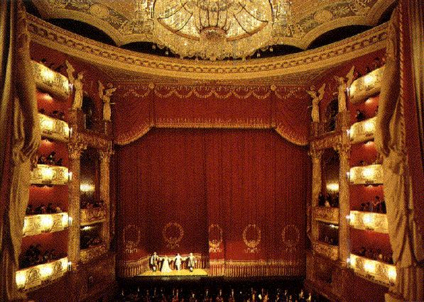
Bayrische Staatsoper in Munich
If all this seems like too much time and expense, there is one final option, and it's free. Nearly all European festival productions—including everything at Salzburg, Bayreuth and Glyndebourne—are Webcast (and occasionally even videocast), often repeatedly. With a couple of clicks of the mouse, anyone with high-speed Internet access can pick up an endless stream of operas, many with very high sound quality. Wherever you are, in Europe or across the globe, summer opera is close by.
Moravcsik teaches government and directs the European Union Center at Harvard University.

© 2004 Newsweek, Inc.

