Print Edition: COVER STORY (31 January 2005)

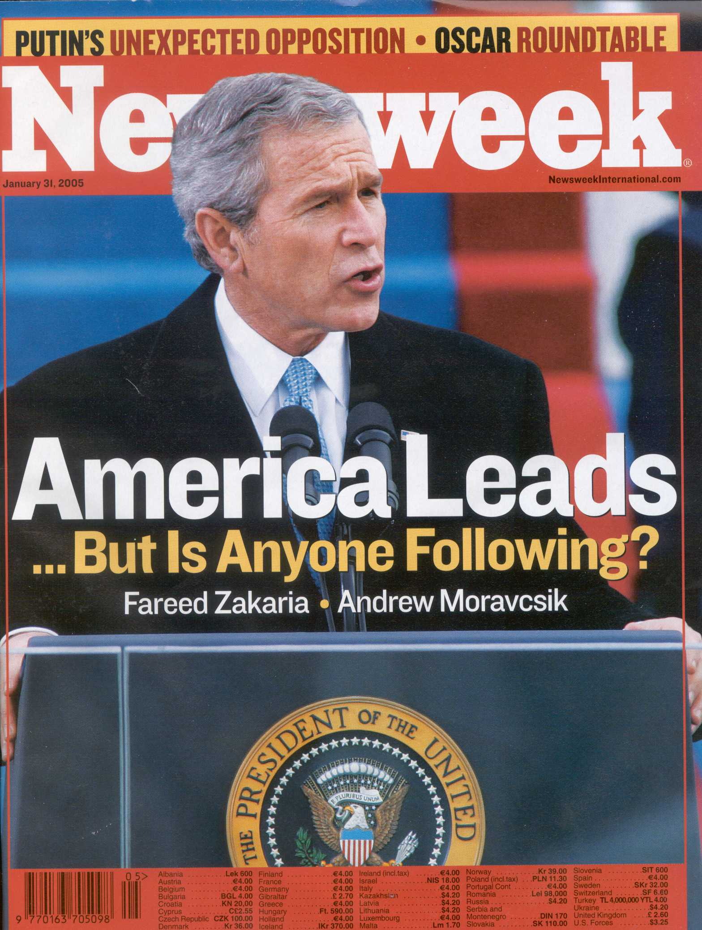

Web Edition: http://www.msnbc.msn.com/id/6857387/site/newsweek/

Dream on America
The U.S. Model: For years, much of the world did aspire to the American way of life. But today countries are finding more appealing systems in their own backyards.

By Andrew Moravcsik
Newsweek International

Jan. 31 issue - Not long ago, the American dream was a global dream. Not only Americans saw themselves as a beacon unto nations. So did much of the rest of the world. East Europeans tuned into Radio Free Europe. Chinese students erected a replica of the Statue of Liberty in Tiananmen Square.

You had only to listen to George W. Bush's Inaugural Address last week (invoking "freedom" and "liberty" 49 times) to appreciate just how deeply Americans still believe in this founding myth. For many in the world, the president's rhetoric confirmed their worst fears of an imperial America relentlessly pursuing its narrow national interests. But the greater danger may be a delusional America—one that believes, despite all evidence to the contrary, that the American Dream lives on, that America remains a model for the world, one whose mission is to spread the word.

The gulf between how Americans view themselves and how the world views them was summed up in a poll last week by the BBC. Fully 71 percent of Americans see the United States as a source of good in the world. More than half view Bush's election as positive for global security. Other studies report that 70 percent have faith in their domestic institutions and nearly 80 percent believe "American ideas and customs" should spread globally.

Foreigners take an entirely different view: 58 percent in the BBC poll see Bush's re-election as a threat to world peace. Among America's traditional allies, the figure is strikingly higher: 77 percent in Germany, 64 percent in Britain and 82 percent in Turkey. Among the 1.3 billion members of the Islamic world, public support for the United States is measured in single digits. Only Poland, the Philippines and India viewed Bush's second Inaugural positively.

Tellingly, the anti-Bushism of the president's first term is giving way to a more general anti-Americanism. A plurality of voters (the average is 70 percent) in each of the 21 countries surveyed by the BBC oppose sending any troops to Iraq, including those in most of the countries that have done so. Only one third, disproportionately in the poorest and most dictatorial countries, would like to see American values spread in their country. Says Doug Miller of GlobeScan, which conducted the BBC report: "President Bush has further isolated America from the world. Unless the administration changes its approach, it will continue to erode America's good name, and hence its ability to effectively influence world affairs." Former Brazilian president Jose Sarney expressed the sentiments of the 78 percent of his countrymen who see America as a threat: "Now that Bush has been re-elected, all I can say is, God bless the rest of the world."

The truth is that Americans are living in a dream world. Not only do others not share America's self-regard, they no longer aspire to emulate the country's social and economic achievements. The loss of faith in the American Dream goes beyond this swaggering administration and its war in Iraq. A President Kerry would have had to confront a similar disaffection, for it grows from the success of something America holds dear: the spread of democracy, free markets and international institutions—globalization, in a word.

Countries today have dozens of political, economic and social models to choose from. Anti-Americanism is especially virulent in Europe and Latin America, where countries have established their own distinctive ways—none made in America. Futurologist Jeremy Rifkin, in his recent book "The European Dream," hails an emerging European Union based on generous social welfare, cultural diversity and respect for international law—a model that's caught on quickly across the former nations of Eastern Europe and the Baltics. In Asia, the rise of autocratic capitalism in China or Singapore is as much a "model" for development as America's scandal-ridden corporate culture. "First we emulate," one Chinese businessman recently told the board of one U.S. multinational, "then we overtake."

Many are tempted to write off the new anti-Americanism as a temporary perturbation, or mere resentment. Blinded by its own myth, America has grown incapable of recognizing its flaws. For there is much about the American Dream to fault. If the rest of the world has lost faith in the American model—political, economic, diplomatic—it's partly for the very good reason that it doesn't work as well anymore.

AMERICAN DEMOCRACY: Once upon a time, the U.S. Constitution was a revolutionary document, full of epochal innovations—free elections, judicial review, checks and balances, federalism and, perhaps most important, a Bill of Rights. In the 19th and 20th centuries, countries around the world copied the document, not least in Latin America. So did Germany and Japan after World War II. Today? When nations write a new constitution, as dozens have in the past two decades, they seldom look to the American model.

When the Soviets withdrew from Central Europe, U.S. constitutional experts rushed in. They got a polite hearing, and were sent home. Jiri Pehe, adviser to former president Vaclav Havel, recalls the Czechs' firm decision to adopt a European-style parliamentary system with strict limits on campaigning. "For Europeans, money talks too much in American democracy. It's very prone to certain kinds of corruption, or at least influence from powerful lobbies," he says. "Europeans would not want to follow that route." They also sought to limit the dominance of television, unlike in American campaigns where, Pehe says, "TV debates and photogenic looks govern election victories."

So it is elsewhere. After American planes and bombs freed the country, Kosovo opted for a European constitution. Drafting a post-apartheid constitution, South Africa rejected American-style federalism in favor of a German model, which leaders deemed appropriate for the social-welfare state they hoped to construct. Now fledgling African democracies look to South Africa as their inspiration, says John Stremlau, a former U.S. State Department official who currently heads the international relations department at the University of Witwatersrand in Johannesburg: "We can't rely on the Americans." The new democracies are looking for a constitution written in modern times and reflecting their progressive concerns about racial and social equality, he explains. "To borrow Lincoln's phrase, South Africa is now Africa's 'last great hope'."

Much in American law and society troubles the world these days. Nearly all countries reject the United States' right to bear arms as a quirky and dangerous anachronism. They abhor the death penalty and demand broader privacy protections. Above all, once most foreign systems reach a reasonable level of affluence, they follow the Europeans in treating the provision of adequate social welfare is a basic right. All this, says Bruce Ackerman at Yale University Law School, contributes to the growing sense that American law, once the world standard, has become "provincial." The United States' refusal to apply the Geneva Conventions to certain terrorist suspects, to ratify global human-rights treaties such as the innocuous Convention on the Rights of the Child or to endorse the International Criminal Court (coupled with the abuses at Abu Ghraib and Guantanamo) only reinforces the conviction that America's Constitution and legal system are out of step with the rest of the world.

ECONOMIC PROSPERITY: The American Dream has always been chiefly economic—a dynamic ideal of free enterprise, free markets and individual opportunity based on merit and mobility. Certainly the U.S. economy has been extraordinarily productive. Yes, American per capita income remains among the world's highest. Yet these days there's as much economic dynamism in the newly industrializing economies of Asia, Latin America and even eastern Europe. All are growing faster than the United States. At current trends, the Chinese economy will be bigger than America's by 2040. Whether those trends will continue is not so much the question. Better to ask whether the American way is so superior that everyone else should imitate it. And the answer to that, increasingly, is no.

Much has made, for instance, of the differences between the dynamic American model and the purportedly sluggish and overregulated "European model." Ongoing efforts at European labor-market reform and fiscal cuts are ridiculed. Why can't these countries be more like Britain, businessmen ask, without the high tax burden, state regulation and restrictions on management that plague Continental economies? Sooner or later, the CW goes, Europeans will adopt the American model—or perish.

Yet this is a myth. For much of the postwar period Europe and Japan enjoyed higher growth rates than America. Airbus recently overtook Boeing in sales of commercial aircraft, and the EU recently surpassed America as China's top trading partner. This year's ranking of the world's most competitive economies by the World Economic Forum awarded five of the top 10 slots—including No. 1 Finland—to northern European social democracies. "Nordic social democracy remains robust," writes Anthony Giddens, former head of the London School of Economics and a "New Labour" theorist, in a recent issue of the New Statesman, "not because it has resisted reform, but because it embraced it."

This is much of the secret of Britain's economic performance as well. Lorenzo Codogno, co-head of European economics at the Bank of America, believes the British, like Europeans elsewhere, "will try their own way to achieve a proper balance." Certainly they would never put up with the lack of social protections afforded in the American system. Europeans are aware that their systems provide better primary education, more job security and a more generous social net. They are willing to pay higher taxes and submit to regulation in order to bolster their quality of life. Americans work far longer hours than Europeans do, for instance. But they are not necessarily more productive—nor happier, buried as they are in household debt, without the time (or money) available to Europeans for vacation and international travel. George Monbiot, a British public intellectual, speaks for many when he says, "The American model has become an American nightmare rather than an American dream."

Just look at booming Britain. Instead of cutting social welfare, Tony Blair's Labour government has expanded it. According to London's Centre for Policy Studies, public spending in Britain represented 43 percent of GDP in 2003, a figure closer to the Eurozone average than to the American share of 35 percent. It's still on the rise—some 10 percent annually over the past three years—at the same time that social welfare is being reformed to deliver services more efficiently. The inspiration, says Giddens, comes not from America, but from social-democratic Sweden, where universal child care, education and health care have been proved to increase social mobility, opportunity and, ultimately, economic productivity. In the United States, inequality once seemed tolerable because America was the land of equal opportunity. But this is no longer so. Two decades ago, a U.S. CEO earned 39 times the average worker; today he pulls in 1,000 times as much. Cross-national studies show that America has recently become a relatively difficult country for poorer people to get ahead. Monbiot summarizes the scientific data: "In Sweden, you are three times more likely to rise out of the economic class into which you were born than you are in the U.S."

Other nations have begun to notice. Even in poorer, pro-American Hungary and Poland, polls show that only a slender minority (less than 25 percent) wants to import the American economic model. A big reason is its increasingly apparent deficiencies. "Americans have the best medical care in the world," Bush declared in his Inaugural Address. Yet the United States is the only developed democracy without a universal guarantee of health care, leaving about 45 million Americans uninsured. Nor do Americans receive higher-quality health care in exchange. Whether it is measured by questioning public-health experts, polling citizen satisfaction or survival rates, the health care offered by other countries increasingly ranks above America's. U.S. infant mortality rates are among the highest for developed democracies. The average Frenchman, like most Europeans, lives nearly four years longer than the average American. Small wonder that the World Health Organization rates the U.S. healthcare system only 37th best in the world, behind Colombia (22nd) and Saudi Arabia (26th), and on a par with Cuba.

The list goes on: ugly racial tensions, sky-high incarceration rates, child-poverty rates higher than any Organization for Economic Cooperation and Development country except Mexico—where Europe, these days, inspires more admiration than the United States. "Their solutions feel more natural to Mexicans because they offer real solutions to real, and seemingly intractable, problems," says Sergio Aguayo, a prominent democracy advocate in Mexico City, referring to European education, health care and social policies. And while undemocratic states like China may, ironically, be among the last places where the United States still presents an attractive political and social alternative to authoritarian government, new models are rising in prominence. Says Julie Zhu, a college student in Beijing: "When I was in high school I thought America was this dreamland, a fabled place." Anything she bought had to be American. Now that's changed, she says: "When people have money, they often choose European products." She might well have been talking about another key indicator. Not long ago, the United States was destination number one for foreign students seeking university educations. Today, growing numbers are going elsewhere—to other parts of Asia, or Europe. You can almost feel the pendulum swinging.

FOREIGN POLICY: U.S. leaders have long believed military power and the American Dream went hand in hand. World War II was fought not just to defeat the Axis powers, but to make the world safe for the United Nations, the precursor to the —World Trade Organization, the European Union and other international institutions that would strengthen weaker countries. NATO and the Marshall Plan were the twin pillars upon which today's Europe were built.

Today, Americans make the same presumption, confusing military might with right. Following European criticisms of the Iraq war, the French became "surrender monkeys." The Germans were opportunistic ingrates. The British (and the Poles) were America's lone allies. Unsurprisingly, many of those listening to Bush's Inaugural pledge last week to stand with those defying tyranny saw the glimmerings of an argument for invading Iran: Washington has thus far shown more of an appetite for spreading ideals with the barrel of a gun than for namby-pamby hearts-and-minds campaigns. A former French minister muses that the United States is the last "Bismarckian power"—the last country to believe that the pinpoint application of military power is the critical instrument of foreign policy.

Contrast that to the European Union—pioneering an approach based on civilian instruments like trade, foreign aid, peacekeeping, international monitoring and international law—or even China, whose economic clout has become its most effective diplomatic weapon. The strongest tool for both is access to huge markets. No single policy has contributed as much to Western peace and security as the admission of 10 new countries—to be followed by a half-dozen more—to the European Union. In country after country, authoritarian nationalists were beaten back by democratic coalitions held together by the promise of joining Europe. And in the past month European leaders have taken a courageous decision to contemplate the membership of Turkey, where the prospect of EU membership is helping to create the most stable democratic system in the Islamic world. When historians look back, they may see this policy as being the truly epochal event of our time, dwarfing in effectiveness the crude power of America.

The United States can take some satisfaction in this. After all, it is in large part the success of the mid-century American Dream—spreading democracy, free markets, social mobility and multilateral cooperation—that has made possible the diversity of models we see today. This was enlightened statecraft of unparalleled generosity. But where does it leave us? Americans still invoke democratic idealism. We heard it in Bush's address, with his apocalyptic proclamation that "the survival of liberty in our land increasingly depends on the success of liberty in other lands." But fewer and fewer people have the patience to listen.

Headlines in the British press were almost contemptuous: DEFIANT BUSH DOES NOT MENTION THE WAR, HAVE I GOT NUKES FOR YOU and HIS SECOND-TERM MISSION: TO END TYRANNY ON EARTH. Has this administration learned nothing from Iraq, they asked? Can this White House really expect to command support from the rest of the world, with its different strengths and different dreams? The failure of the American Dream has only been highlighted by the country's foreign-policy failures, not caused by them. The true danger is that Americans do not realize this, lost in the reveries of greatness, speechifying about liberty and freedom.

Andrew Moravcsik is Professor of Politics and Director of the European Union Program at Princeton University.

With Christian Caryl in Tokyo, Katka Krosnar in Prague, Mac Margolis in Rio de Janeiro, Tracy Mcnicoll in Paris, Paul Mooney in Beijing, Henk Rossouw in Johannesburg and Marie Valla in London © 2005 Newsweek, Inc

