Forthcoming in the 14 March issue:

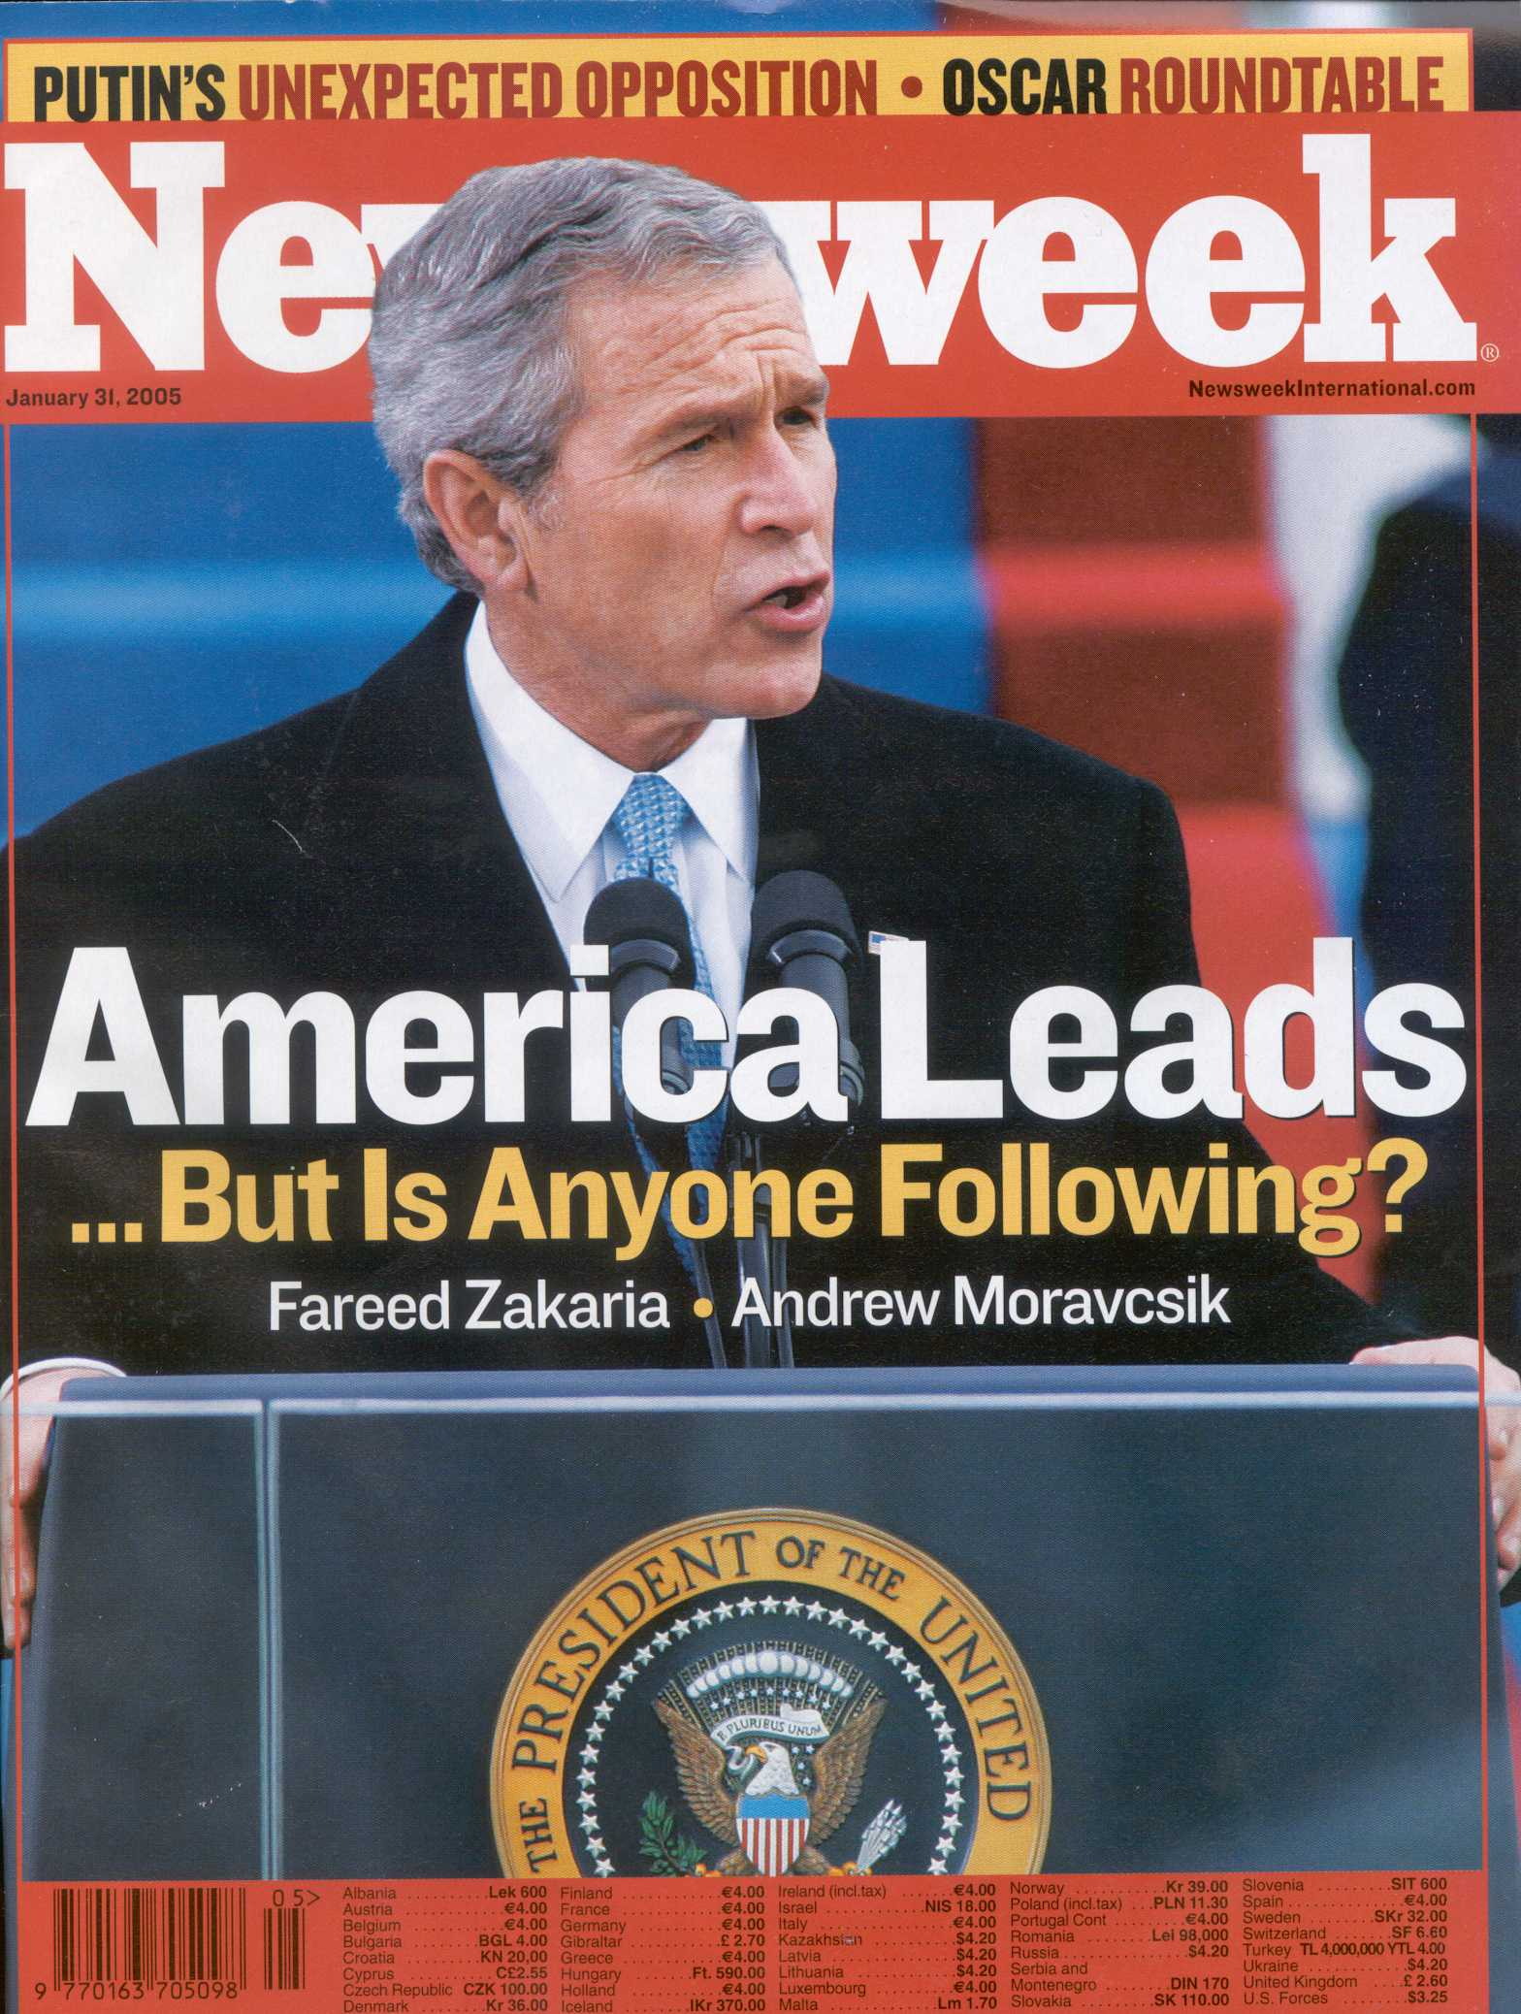
Mail Call

Death of The American Dream?
Thank you for publishing Andrew
Moravcsik's article "Dream On, America,"
(Jan. 31), for looking at the facts on the
ground and telling the truth about what
America represents in the world today.
Americans' tight grip on a mythological past
threatens the well-being of this world.
Barbara Comnes
San Anselmo, California

Why did Andrew Moravcsik's excel-
lent commentary on the myth of the
American Dream run only in newsweek's
international edition? The failure of U.S.
mainstream media to reflect this kind of al
ternative viewpoint to the American public
is why the myth persists and why Americans
have been so out of touch with the rest of the
world on Iraq. Are publishers are afraid of
the response from indignant "patriots" that
such a perspective might receive?
Coralie Campobasso
Pozuelo, Spain

Your insightful article explained
how differently the world now views
America and why. Contrary to most
Americans' view that the rest of the world
strives to be like them, you reported, accu
rately, that the world sees America more
honestly, that it is not a symbol of hope and
near-perfection that it once was to others.
But

the fault is not in the obviously unilateral
foreign policy of the Bush administration
which is what most Americans automatical
ly assume but rather, as you pointed out, in a
system that is beginning to fail in places and
be surpassed in others. For example, as your
graphic vividly demonstrated, while Greece
ranks first in voter participation with an 89
percent turnout, the U.S. ranks 16th with 46
percent. Sweden ranks lowest in child
poverty (2.6 percent), the U.S. ranks 22nd at
22.4 percent. But if most Americans do not
realize the nature of America's role in the
world and how it is perceived abroad, it is al
so because American media is obsessed with
all things American to the exclusion of a bal-
anced global view. I think Newsweek has
been a bright exception to such myopia.
J. W.Waring
Prague, Czech Republic

Why do you hold Europe up as a model when
it has high unemployment and high
taxes? America stopped the genocide in the
Balkans; Europe did nothing. But for
America, it would not even exist today.
Brian Nash
Via internet

So, we Americans are a bunch of gun-
totin' bullies living in the social equivalent
of a third world country, with an outdated
constitution and inadequate institutions,
where a few super-rich folks crack the whip
over the backs of the overworked masses
until we die at an early age from lack of
proper health care? And oh yes, everybody
hates us, too. But they really shouldn't since
we're too dumb to know any better 'cuz our
schools are so bad. Hey, thanks Newsweek,
for setting us straight.
Rodney Schulling
Tk, Moldova

Andrew Moravcsik's article was
both prophetic and poetic. The story was
truly a eulogy to the American dream but I
have faith that, as a people, we Americans
will recover from the disease of arrogance
and self-deception. The real truth is that
we are not a country of red and blue, black
and white, liberal and conservative. We
are all Americans and have many common
values and beliefs.
John R. Clarke
Highland, Michigan

Sincere thanks, Newsweek, for try-
ing to help us Americans see the truth about
ourselves. Every society nurtures certain
myths about itself but in America, the denial
of things gone wrong with many of our core
systems and policies-so obvious to the rest
of the world-is so complete that we have
lost the ability to self-correct. It is precisely
the lack of honest self-reflection that has al
lowed our elected officials to lead us into the
tragedy that is Iraq and the hopelessly mis
guided "war on terror." The insights and fac
tual admissions laid out in your special re
port are, sad to say, way late in coming. We
can only hope it's better late than never.
Donald Boone
Tokyo, Japan

I have rarely read such anti-Ameri
can raving in an American magazine.
Articles like this one with their knee jerk
demonization of Bush don't help
Europeans get over their obsessive hatred
of our president. I have endured similar
anti-American rants by international stu
dents in France. When I ask them if they've
ever been to the States, a far-off look comes
over their face as they say, "My dream is to
live in America." When push comes to
shove, they know that the States has real
freedom and economic opportunity. They
complain about America only until they
have an opportunity to go there.
Scott Petersen
lonjumeau, France

Congratulations, Newsweek! I
praise you for your courage in publishing
such a refutation of your average American
reader's beliefs. It must be shocking to have
Prof. Moravcsik peel the onion of
American myths, one layer at a time until
all that's left is teary eyes. That Americans
believe their country to be the guardian of
democracy in the world-if not its
founder!-is sad but relatively harmless. To
have the U.S. Commander-in-Chief believe
this is dangerous. The greatest mistakes
are made when we feel we are beyond
questioning as George W. Bush clearly
feels he is. I just hope that there are enough
people in America who arenot afraid to
throw at him the kind of questions your
special report raises.
Vasilis A.P.Metaxas
Nicosia, Cyprus

The opinion of people in those
countries which have traditionally been
U.S. allies shatters the myth that America
remains a model for the world. During the
20th century, people everywhere aspired to
follow America's democratic model. Now,
as citizen of a third world country, which
has been close to the United States since its
independence from colonial rule in 1947, I
have to agree with your writers: the U.S.
government is viewed by foreigners like us
as partial, biased, narrow-minded, selective
in applying its policies of human rights and
nuclear disaramament. For example,
America is aggressively pressurizing North
Korea and Iran to scrap their nuclear pro
grams but has done nothing to contain
Israel which already has a significant arse
nal of nuclear weapons. As long as such
contradictions exist in U.S. policies, mis
trust of people outside America will keep
growing and America will be further isolat
ed from the rest of the world.
Tarique Mahmood Malak
Risalpur, Pakistan

Iin the graphic accompanying "Dream
on, America," you incorrectly stated that the
United States does not recognize the
Chemical Weapons Convention. In fact, the
United States has been a full party to the
Convention since 1997 and actively imple
ments it by destroying chemical weapons.
Over the years, the United States has invest
ed billions of dollars in the disposal of its de
clared chemical weapons arsenal literally 24
hours a day and it partners with other coun
tries in ensuring that the world is forever
freed of these horrific weapons.
Rogelio Pfirter
Director-General
Organisation for the Prohibition of Chemical
Weapons
The Hague, Netherlands

Editor's Note: While the United States has
signed and ratified the CWC, it has refused
to forswear the use of non-lethal chemical
weapons (which are permitted for domestic
disturbances but banned in war) in Iraq.

Your cover line asks, "America
Leads...But Is Anyone Following?" Nobody
wants to follow Bush's course because the
spreading of freedom has become America's
offensive weapon-one for which Bush has
no licence. He says that the best hope for
peace in our world is the expansion of free
dom in the whole world. But freedom can
not be ordered or "doctrined": it has to
be initiated in the minds and hearts of peo
ple. It certainly will not come into being
through the U.S. Army.
Peter Jehle
Niederrieden, Germany

