Print edition: Saturday, 22 September 2007 (Arts and Weekend)
Web edition: http://www.ft.com/cms/s/0/523a7fa6-67e4-11dc-8906-0000779fd2ac.html


ARTS AND WEEKEND
Performing Arts
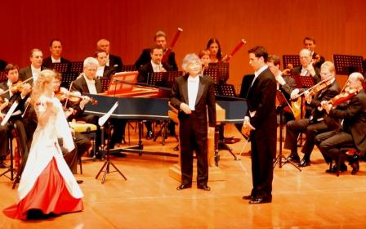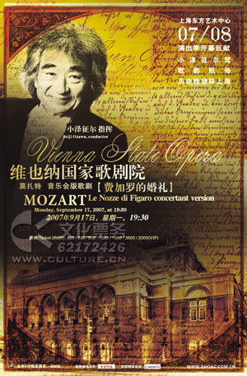

A conductor worth watching
By Andrew Moravcsik
Posters across Shanghai featured a dreamy picture of the 72-year-old Japanese conductor Seiji Ozawa and the facade of the Vienna State Opera. The fine print announced Mozart’s Le Nozze di Figaro in concert performance, singers to be announced. The price: up to RMB3,200 (£210) – to my knowledge, China’s most expensive classical concert this year.
In Seoul, South Korea, the next stop on the tour (before Taipei and Singapore), the cost of seats (half at Won350,000-450,000 or £190-240) triggered a public scandal. One Korean fan complained online: “Why not just book a plane ticket to Austria?” The local concert organiser felt compelled to publicise the balance sheet, revealing that 85 per cent of the take went to the orchestra, singers and Ozawa himself.
There was no scandal in Shanghai, perhaps because the audience contained so many Japanese, many there to see a national hero conducting one of the great European orchestras. Watching Ozawa, it turned out, proved to be the high point of the evening, but too often at the expense of the music.
Despite a recent illness, Ozawa remains an astonishingly fluid and balletic conductor, using his entire body to direct the orchestra. A tiny, elfin figure, conducting as always entirely from memory and without a baton, he was untethered from the podium, dancing across the stage, often turning his back on the orchestra to face the singers, slipping in and among them like a Bunraku puppeteer.
For almost 30 years, until 2002, Ozawa was music director of the Boston Symphony Orchestra, so his unconventional direction was familiar to many US concertgoers. But here his style, deft and refreshing at first, became monotonous and finally just relentless. Despite some fine details, the tempos were too swift, the dynamics too loud, and the overall structure too homogeneous – with none of the delicacy, transparency and rhythmic attack early music players use as offsets. The acoustic glare of Shanghai Oriental Arts Centre exacerbated the problem.
By “Porgi amor” at the start of Act 2, the desire to hear the young Romanian soprano Cellia Costea take a breath and linger over the notes was already overwhelming. Costea shaded the subsequent letter duet subtly, but pushed her voice in grand moments with unpleasantly harsh and metallic results. Her performance was typical of the mystery cast, only one of whom turned out to be an international figure.
Baritone Luca Pisaroni has recently made a name as Figaro, notably in an acclaimed René Jacobs DVD. A handsome young Italian, he commanded the stage and enunciated his native language with ease. His tightly focused baritone was a superb instrument in the early music style, though he lacked the commanding resonance to stand up to a modern Mozart orchestra such as the Viennese.
Beside him stood an uneven mélange of veterans and newcomers drawn from the pool of competent second-tier singers who populate Vienna. Ildikó Raimondi was note-perfect but generic, lacking the winning personality and sparkling recitative that can render Susanna memorable. With blond curls and a scarlet and cream silk gown, she looked like a refugee from Fledermaus. Fellow Kammersänger Peter Weber’s gruff and reedy Almaviva suggested that recent forays as Sachs and Kurwenal have robbed his voice of Mozartian elegance, along with the F-sharp that should have crowned his big aria. Lightweight mezzo Michaela Selinger conveyed a winning, stylish Cherubino. Aura Twarowska’s dusky Marcellina sparked curiosity about her Eboli and Amneris.
With a more nuanced musical vision and first-rate singers, Ozawa’s striking gifts might have made for a truly insightful evening of opera. Here one felt one was watching a quirky conceptual artist at work – but as is so often the case with aggressively marketed conceptual art, in the end one had to ask: was it really worth the money?

